

## An Internship Report

**On**

**GOOGLE ANDROID DEVELOPER**

Submitted in accordance with the requirement for the degree of

**BACHELOR OF TECHNOLOGY IN**

**KRISHNA CHAITANYA INSTITUTE OF TECHNOLOGY & SCIENCES**

## Submitted by: VITTA SIVA SHANKAR

## Reg. No: 20JU1A05E1

Under the Esteemed Guidance of

**Dr.J.V.ANIL KUMAR,M.Tech, Ph.D**

**( Professor & H.O.D)**

Department of

## COMPUTER SCIENCE & ENGINEERING



**KRISHNA CHAITANYA INSTITUTE OF TECHNOLOGY & SCIENCES**

## (Approved by AICTE, NewDelhi & Affiliated to JNTU, KAKINADA). Accredited by NAAC, Markapur, Prakasam Dt., Andhra Pradesh.

## (2023-2024)

**SEMESTER INTERNSHIP**

Name of the Student: **VITTA SIVA SHANKAR**

Name of the College: **KRISHNA CHAITANYA INSTITUTE OF TECHNOLOGY**

**& SCIENCES**

Registration Number: **2OJU1A05E1**

Period of Internship: **10 Weeks** From: **9-01-2024** To :**9-03-2024**. Name &Address of the Intern Organization: **AICTE-EduSkills**

JNTU KAKINADA, UNIVERSITY 2023-24

**Student’s Declaration**

I, **VITTA SIVA SHANKAR** a student of Internship Program, Reg.No. **20JU1A05E1** of the Department of **COMPUTER SCIENCE & ENGINEERING, KRISHNA CHAITANYA INSTITUTE OF TECHNOLOGY & SCIENCES** do hereby declare that I have completed the mandatory internship from 9-01-2024 to 9-03-2024. in **EduSkills Foundation** with **AICTE.**

(Signature and Date)

**Official Certification**

This is to certify that **VITTA SIVA SHANKAR** Reg. No. **2OJU1A05E1** has completed his internship in **AICTE-Eduskills Foundation** on **GOOGLE ANDROID DEVELOPER,** under my supervision apart of partial fulfilment of the requirement for the Degree of **BACHELOR OF TECHNOLOGY** in the Department of **COMPUTER SCIENCE & ENGINEERING,KRISHNA CHAITANYA INSTITUTE OF TECHNOLOGY & SCIENCES.**

(SIGNATURE WITH DATE AND SEAL)

**Endorsements**

Faculty Guide

Head of the Department

Principal

# CERTIFICATE FROM INTERN ORGANIZATION

This to certify that **VITTA SIVA SHANKAR** Reg.No.**2OJU1A05E1** of **KRISHNA CHAITANYA INSTITUTE OF TECHNOLOGY & SCIENCES** underwent Internship in **GOOGLE ANDROID DEVELOPER** with **EduSkills-Foundation , AICTE** from 9-01-2024 to 9-03-2024. The overall performance of the intern during his internship is found to be **Satisfactory.**

Authorised signatory with seal

# Certificate From Intern Organization

# 

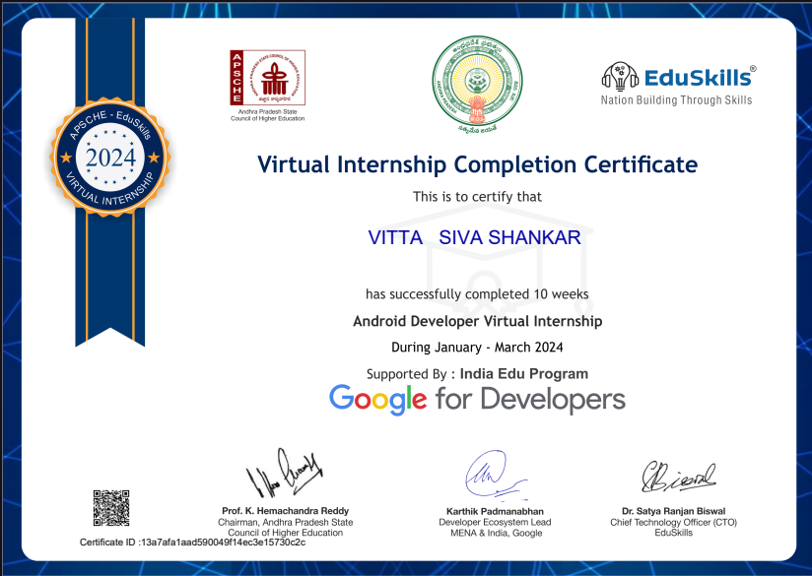

## ACKNOWLEDGEMENT

I take this opportunity to express my deep gratitude of appreciation to all those who encourage us for successful completion of the internship.

I wish to convey sincere thanks to chairman of our college **Mr**. **ANNA RAMBABU GARU**, and secretary and correspondent **Mr**. **ANNA KRISHNA CHAITANYA GARU.**

I wish to express my deepest sense of gratitude and my sincere thanks to **Dr.V.KRISHNA REDDY**, PRINCIPAL of KITS college for his suggestions.

I wish to express my sincere gratitude to **Dr. J.V. ANIL KUMAR sir, HOD** of CSE Department, for his consistent help and encouragement to complete the internship.

I express my sincere thanks to my internship Co-Ordinator **Mrs. A. AMRUTHAVALLI, M. tech, Ph. D, Associate Professor** for his suggestions and constant source of information for me.

I sincerely express thanks to my **internship mentors** for their excellent suggestions and extended co-operation for its success.

I whole heartedly express my thanks to all **CSE department faculty members** for their full-fledged co-operation towards completion of my internship.

I am also thankful to all who helped me directly and indirectly in the successful completion of this internship.

**Internship Associate:**

VITTA SIVA SHANKAR -20JU1A05E1

**CONTENTS**

CHAPTER 1: EXECUTIVE SUMMARY 1

CHAPTER 2: OVERVIEW OF THE ORGANISATION 2-6

* 1. Introduction of the organization… 2
  2. Vision, Mission and Values of The Organisation 3
  3. Policy of the Organization, in relation to the intern role 3-6

CHAPTER 3: INTERNSHIP PART 7-8

* 1. Need for basics of Data Analytics 7
  2. Internship and Its Importance 7-8
  3. Intern Responsibilities 8
  4. Skills Acquired during Internship 8

CHAPTER 4: WEEKLY REPORTS 9-29

ACTIVITY LOG FOR WEEK-1 9

WEEKLY REPORT 10

ACTIVITY LOG FOR WEEK-2 11

WEEKLY REPORT 12

ACTIVITY LOG FOR WEEK-3 13

WEEKLY REPORT 14

ACTIVITY LOG FOR WEEK-4 15

WEEKLY REPORT 16

ACTIVITY LOG FOR WEEK-5 17

WEEKLY REPORT 18

ACTIVITY LOG FOR WEEK-6 19

WEEKLY REPORT 20

ACTIVITY LOG FOR WEEK-7 21

WEEKLY REPORT 22

ACTIVITY LOG FOR WEEK-8 23

WEEKLY REPORT 24

ACTIVITY LOG FOR WEEK-9 25

WEEKLY REPORT 26

ACTIVITY LOG FOR WEEK-9 27

WEEKLY REPORT 28-29

CHAPTER -5 OUTCOMES DESCRIPTION 30-38

* 1. Describe the work environment you have experienced 30-31
  2. Describe the real time technical skills you have acquired 32-35
  3. Describe the managerial skills you have acquired 35-37
  4. Describing how I could I improve my communication skills 37-38

**STUDENT SELF- EVALUATION OF THE SEMESTER INTERNSHIP 39**

**EVALUATION BY THE SUPERVISIOR OF THE INTERN ORGANISATION 40**

**EVALUATION 41**

**INTERNAL ASSESSMENT STATEMENT 42-44**

# CHAPETER-1: EXCEUTIVE SUMMARY

An Android Developer is a Software Developer who specializes in designing applications for the Android marketplace. The Android marketplace is the direct competitor to Apple’s app store. This means most of an Android Developer’s job revolves around creating the apps we use on our smartphones and tablets. Android Developers can either work in-house for a large organization, or they can be employed by an App Development agency.The role of Android Developer is a skilled, entry-level position. Employers often require a bachelor’s degree in software development or a related field, but they typically do not require work experience as an Android Developer. The next rung on the career ladder would be Senior Android Developer, which involves taking on leadership and mentorship roles. According to the Bureau of Labor Statistics, demand for Software Developers, which includes Android Developers, is expected to rise a whopping 17 percent through 2024.

**Learning objectives:**

* Creating robust mobile applications and learn how to integrate them with other services
* Creating intuitive, reliable mobile apps using the android services and components
* Create a seamless user interface that works with different mobile screens

## Learning outcomes:

* Build enterprise level mobile applications with Kotlin on Android
* Understand both the basic and advanced concepts of Kotlin
* Understand why use Kotlin over Java
* Install and configure Android Studio
* Explain and use key Android programming concepts
* Deploy the application on Google Play
* Become a certified Android developer

# CHAPTER-2: OVERVIEW OF THE ORAGANIZATION

## INTRODUCTION OF THE ORGANIZATION

EduSkills is a Non-profit organization which enables Industry 4.0 ready digital workforce in India. Our vision is to fill the gap between Academia and Industry by ensuring world class curriculum access to our faculties and students.We want to completely disrupt the teaching methodologies and ICT based education system in India. We work closely with all the important stakeholders in the ecosystem Students, Faculties, Education Institutions and Central/State Governments by bringing them together through our skilling interventions.Our three-pronged engine targets social and business impact by working holistically on Education, Employment and Entrepreneurship.

Established in 2013, Eduskill is one of India's fastest growing tech-driven training companies that enables academic Institutions, Corporate Houses and Individuals to improve knowledge enrichment and skill enhancement with new-age technologies. We offer innovative means of learning to every member of society and advance better opportunities for Institutions and learners to drive lasting, systematic change in the ecosystem. We are exceptionally skilled and experienced in Whole School transformation using technologies, Corporate Training, employability skills, entry-level talent acquisition, Online assessment, and consulting for organizations with high growth aspirations. The Company is having its presence in 20 State in India and a strong global network of Education Institutions, Collaborators, Partners and Clients. To complement our portfolio, there is a range of additional services coupled with technology such as career mentoring, psychometric testing, Assessment tools, digiboards , bespoke training, and e-learning solutions that makes us **"**One Stop destination enabling Career Excellence".

A platform that offers world-class technical courses designed to prepare individuals for the Industry 4.0 era. These courses are supported by leading global tech companies, ensuring their relevance and quality. The CoE aims to promote skilling and upskilling of the younger generation, providing them with the necessary knowledge and skills to kickstart their careers. By focusing on cutting-edge technologies and industry trends, the CoE aims to equip individuals with the tools needed to succeed in a rapidly evolving job market.

## Vision, Mission & Values Of The Organization Vision:

Transforming the vision of ‘Skilled India’ and Education for To benefit the education ecosystem by providing 360 degree holistic solutions to all the stakeholders.

## Mission:

To positively impact 1 million beneficiaries by 2024. By comphrenive identification of Skill gaps in the students and mapping them with latest and worlds best technical skills.

## Values:

* + - To provide innovative learing aids and services in the education sector.
    - To connect industry-ready professionals, researchers, advanced learners, educators and entrepreneurs who can take best care of stake holders.
    - To extend cutting-edge research, publications and consultancy.
    - To progress global knowledge and skills for the next generation

## Policy of the organization in relation to intern role:

**Orientation interns:** Orient intern in the new workplace. This might take the form of a conventional orientation program or merely a walk around the office, depending on the size of the company. Give interns an overview of the organization; some companies give talks or hand out information about the company’s history, vision and services. Explain who does what and what the intern’s duties will be. Introduce him or her to coworkers.

**Resource requirement of Interns**: Provide the intern a desk/office space and some basic needs like an internet connection (if required), point out the supply room, and introduce the technical support people. Also provide the contact details of some people from organization in case of emergency.

**Guidance/ Regular Feedback**: It’s important to give students lots of feedback. If interns have never done the kind of work before, they’ll want to know if their work is measuring up to organizational expectations.

**Monitoring of intern’s progress every day**: Interns need to maintain a Daily Diary/Daily Log. Industry Supervisor/Faculty Mentor of the student can demand to produce all daily log from the first day of internship at any point of time. Maximum use of short-term

internship has to be ensured for the intern as well as industry. Industry Supervisor should periodically examine what the intern has produced so far and should give suggestions accordingly. Weekly supervision meetings can help to monitor the intern’s work.

## Skills Build Reignite: An Open Platform to Learn Future Skills

Specifically designed for job seekers and business owners as an online learning platform with a plethora of courses related to skills of the future such as Cybersecurity, Data Analy tics, Networking, Cloud Computing etc as well as increasingly valuable human skills, designed by subject matter experts from across the world. The platform allows for custom learning paths and dashboards to trackprogress, and also offers shareable badges for the courses that have been completed.

## INTERNSHIP GUIDELINES OF AICTE:

Internship for students in industries/organization after second, third, fourth, fifth and sixth semester(s) or as per AICTE / affiliating University guidelines. Institutions are encouraged to use AICTE’s Internship Portal for arranging & managing internships. The procedure for arranging internship is given below:

A: Through AICTE Internship Portal A.1: Student can register and find internship

* Step 1: Student can browse and apply for internships via AICTE’s Internship Portal. Industry will select the student based on their selection criteria and will send a provisional offer letter/provisional confirmation (by approving on the portal) to the student.
* Step 2: Student need to obtain NOC (No Objection Certificate) from the TPC of their institute and send it to the industry supervisor, who will approve and send the final offer letter to the students via Email/Post.
* Step 3: Student will join concerned Industry/Organization for Internship on the date as communicated in the final offer letter/Email Confirmation.
* Step 4: Student will undergo industrial training at the concerned Industry / Organization. During the internship, Faculty Mentor will evaluate(s) the performance of students once/twice either by visiting the Industry/Organization or through obtaining periodic reports from students.
* Step 5: Student will submit training report to the industry/organization at the end of internship.
* Step 6: On successful completion of the Internship, Industry/Organisation will issue Internship Certificate to the student.
* Step 7: Student will be evaluated as per evaluation criteria as defined in Chapter 10 of AICTE Internship Policy.

A.2: Institutes can register and find internship for their students: Institute ID will be handled by TPO.

* Step 1: TPO can browse through available internship opportunities and nominate their students for various opportunities accordingly.
* Step 2: Industry/Organisation will either approve or reject the nominations put by TPO. All Students whose nomination is accepted by Industry/Organisation will be eligible for internship. Industry will send final offer letter/email confirmation.
* Step 3: Student(s) will join concerned Industry/Organization for Internship on the date as communicated in the final offer letter/Email Confirmation.
* Step 4: Student(s) will undergo industrial training at the concerned Industry / Organization. During the internship, Faculty Mentor will evaluate(s) the performance of student(s) once/twice either by visiting the Industry/Organization or through obtaining periodic reports from student(s).
* Step 5: Student(s) will submit training report to the industry/organization at the end of internship. 11
* Step 6: Industry/Organisation will issue Internship Certificate to the student(s). • Step 7: Student(s) will be evaluated as per evaluation criteria as defined in Chapter 10 of AICTE Internship Policy.

B: General Procedure:

* Step 1: Request Letter/ Email from the office of Training & Placement cell of the college should go to industry to allot various slots of 4-6 weeks during summer/winter vacation as internship periods for the students. Student(s) request letter/Resume/interest areas may be submitted to industries for their willingness for providing the training. (Sample attached)
* Step 2: Industry will confirm the training slots and the number of seats allocated for internships via Confirmation Letter/Email. In case the student(s) arrange the training

themselves the confirmation letter will be submitted by the students in the office of Training & Placement Cell.

* Step 3: Student(s) will join concerned Industry Organization for Internship on the date as communicated in the final offer letter/Email Confirmation.
* Step 4: Student(s) will undergo industrial training at the concerned Industry Organization. During the internship, Faculty Mentor will evaluate(s) the performance of student(s) oncet wice either by visiting the Industry Organization or through obtaining periodic reports from student(s). Evaluation Report of the students is to be submitted to his/her Faculty Mentor with the consent of Industry persons Trainers. (Sample Attached)
* Step 5: Student(s) will submit training report to the industry organization at the end of internship.
* Step 6: Industry/Organisation will issue Internship Certificate to the student(s).
* Step 7: Student(s) will be evaluated as per evaluation criteria as defined in Chapter 10 of AICTE.

# CHAPTER:3- INTERNSHIP PART

* 1. **Need of android development:**

Android is an open-source [operating system](https://www.interviewbit.com/blog/android-architecture/) for mobiles developed by Google. Android is a popular computing platform based on the Linux operating system. In 10 years, Android has effectively become the world’s most popular operating system by several measures.“Android Development is a process of creating an application that is supported by any operating system using the android development kit or android software development kit(SDK) on android studio. “

# Importance of internship:

An internship is a period of work experience offered by the organisation for a limited period of time. Once confined to graduates, internship is used practice fora wide range of placements in businesses, non-profit organizations and government agencies. They are typically undertaken by students and graduates looking to gain relevant skills and experience in a particular field. The students will get benefit from these placements because they often recruit employees from their best interns, who have known capabilities, thus saving time and money in the long run. Internships for professional careers are similar in some ways. Similar to internships, apprenticeships transition students from vocational school into the workforce. Interns may be college students, and university students, or post graduate adults.

In addition, an internship can be used to build a professional network that can assist with letters of recommendation or lead to future employment opportunities. The benefit of bringing an intern into full time employment is that they are already familiar with the company, therefore needing little to no training. Internships provide current college students with the ability to participate in a fieldof their choice to receive hands-on learning about a particular future career, preparing them for full- time work following graduation.

Companies in search of interns often find and place students in mostlyunpaid internships, for a fee. These companies charge students to assist with research, promising to refund the fee if no internship is found. The programs varyand

aim to provide internship placements at reputable companies. Somecompanies may also provide controlled housing in a new city, mentorship, support, networking, weekend activities or academic credit. Some programs offer extra add-ons such as languages classes, networking events, local excursions, and academic options.

Some companies specifically fund scholarships and grants for low-income applicants. Critics of internship criticize the practice of requiring certain college credits to be obtained only through unpaid internships. Paying for academic credits is a way to ensure students complete the duration of the internship, since they can held accountable by their academic institution. For example, a student may be awarded academic credit only after their university receives a positive review from theintern’s supervisor at the sponsoring organization.

## Internship Responsibilities:

* Fulfilling tasks set out by the mentors from several concepts.
* Attending the online classes on time.
* Performing research on the basic concepts.
* Updating social media platforms and writing copy for posts.
* Creating images for social media posts.

## Skills Acquired during Internship

While getting an internship is one part of the internship process, it is complete only when grasp the relevant skills through my experience. I will get to learn a lot of technical skills. Soft skills are basic necessity to become a professional.

* + - It teaches us how to protect computer operating systems, networks, and data fromcyber-attacks.
    - I learned about how to monitor systems and mitigate threats when they happen.
    - Learned how to protect personal data
    - It improves Cyber posture.
    - It is to ensure that the confidentiality, integrity and availability of data and systems is preserved.
    - Communication skills, Critical thinking & Research and Analysis.

# CHAPTER:4-ACTIVITY LOGS

## ACTIVITY LOG FOR WEEK-1

|  |  |  |  |
| --- | --- | --- | --- |
| **Day & Date** | **Brief description of the daily activity** | **Learning Outcome** | **Person In**  **Charge Signature** |
| Day -1  8-01-24 | I selected the domain of google android  developer | Selection of the domain. |  |
| Day-2 9-01-24 | I got mail from EduSkills foundation- AICTE. | I have gone through google developer website. |  |
| Day-3 11-01-24 | I have gone through the registration process document. | Registration process. |  |
| Day-4 12-01-24 | Registration completion | Registration process. |  |
| Day-5 14-1-24 | Gone through the verification of mail. | __ |  |
| Day-6  16-01-24 | I have got confirmation mail. |  |  |

# WEEKLY REPORT -1

WEEK-1 (From 8/01/2024 to 16/01/2024)

**Objective of the Activity Done**: Registration in EduSkills-AICTE portal. **Detailed Report**: I registered for Android Developer on 12th January 2024. I got mail from EduSkills foundation-AICTE, I have Gone through the

registration process document. I have completed the registration process.I

have gone through the verification of mail and I have got confirmation mial on 16th January,2024.

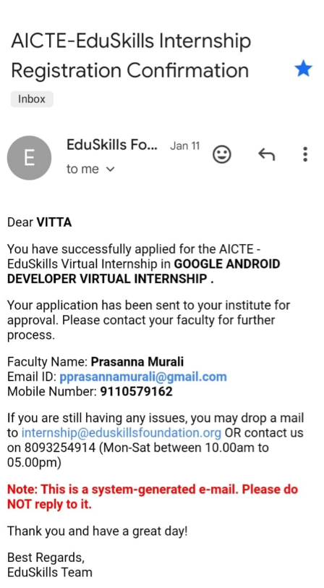 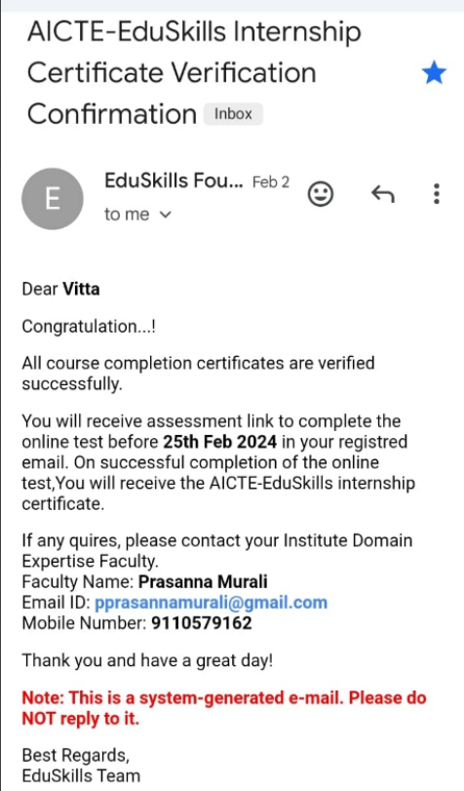

## ACTIVITY LOG FOR WEEK-2

|  |  |  |  |
| --- | --- | --- | --- |
| **Day & Date** | **Brief description of the daily activity** | **Learning Outcome** | **Person In**  **Charge Signature** |
| Day -1  18-01-24 | I have got the webinar link |  |  |
| Day-2 19-01-24 | I have gone through the Introduction of android developer. | About android development. |  |
| Day-3 21-01-24 | Gone through Kotlin fundamentals | Completed the half of the modules. |  |
| Day-4 22-01-24 | Gone through Kotlin fundamentals | Completed the module. |  |
| Day-5 24-1-24 | Gone through the introduction to store &access data using the  keys with datastore. | Completed the half of the module |  |
| Day-6  25-01-24 | Gone through the introduction to store &access data using the  keys with datastore. | Completed the module. |  |

# WEEKLY REPORT -2

WEEK-2 (From18/01/2024 to 25/01/2024)

**Objective of the Activity Done:** Gone through the modules.

**Detailed Report:** I attended the webinar on 18th June 2023. The mentor instructed to complete the modules. Gone through the Kotlin fundamentals. Gone through the Introduction to store & access data using the keys with datastore. Complete all the modules.

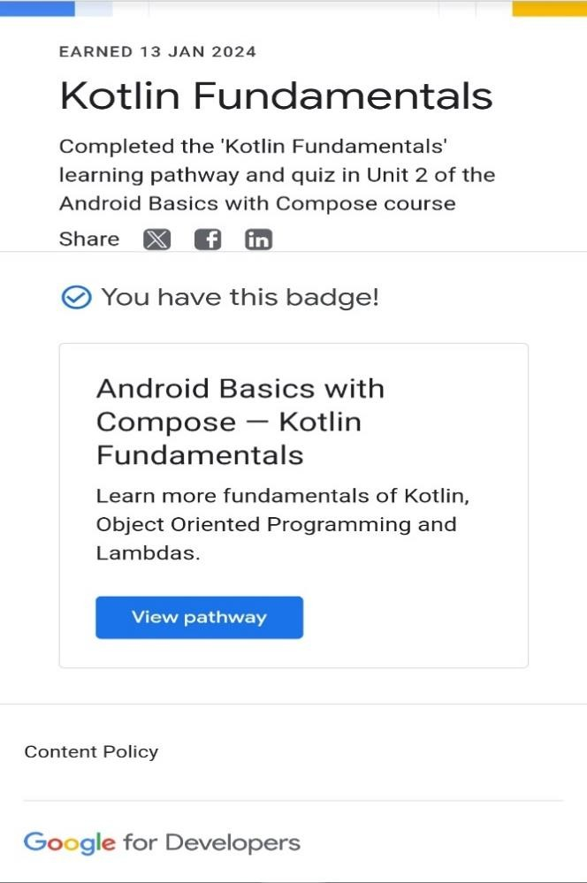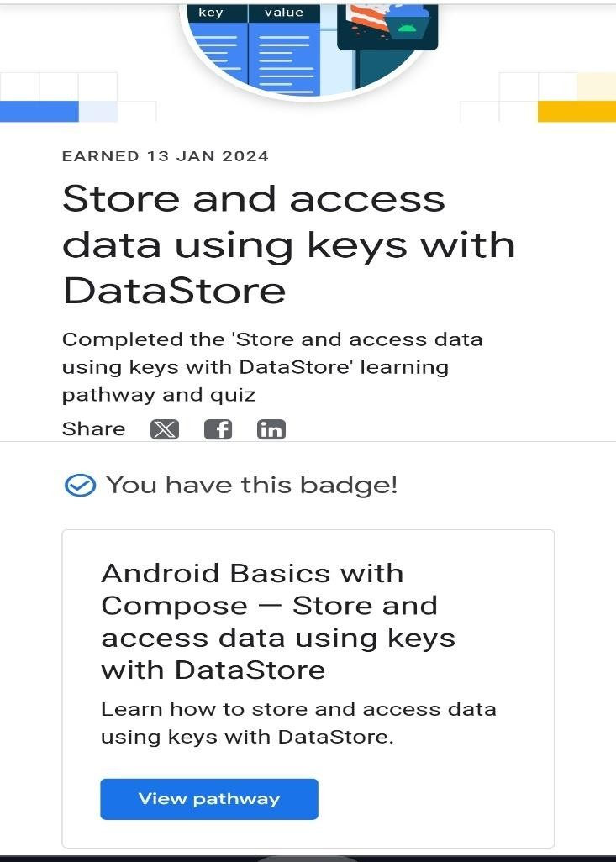

## ACTIVITY LOG FOR WEEK-3

|  |  |  |  |
| --- | --- | --- | --- |
| **Day & Date** | **Brief description of the daily activity** | **Learning Outcome** | **Person In Charge**  **Signature** |
| Day -1  26-01-24 | Gone through joined  the Google developer program | Completed the half of the module. |  |
| Day-2 27-01-24 | I have gone through the joined the Google developer program | Completed the mo module. |  |
| Day-3 28-01-24 | Gone through the build a scrollabale list. | Completed the half of the modules. |  |
| Day-4 29-01-24 | Gone through the build a scrollabale list. | Completed the module. |  |
| Day-5 30-1-24 | Gone through the setup android studio. | Completed the half of the module |  |
| Day-6  1-02-24 | Gone through the setup android studio. | Completed the module. |  |

# WEEKLY REPORT-3

WEEK-3 (From 26/01/2024 to 1/02/2024)

**Objective of the Activity Done:** Gone through the modules.

**Detailed Report:** Gone through the joined the Google developer program. Gone through the build a scrollabale list. Gone through the setup android studio. Completed the modules.

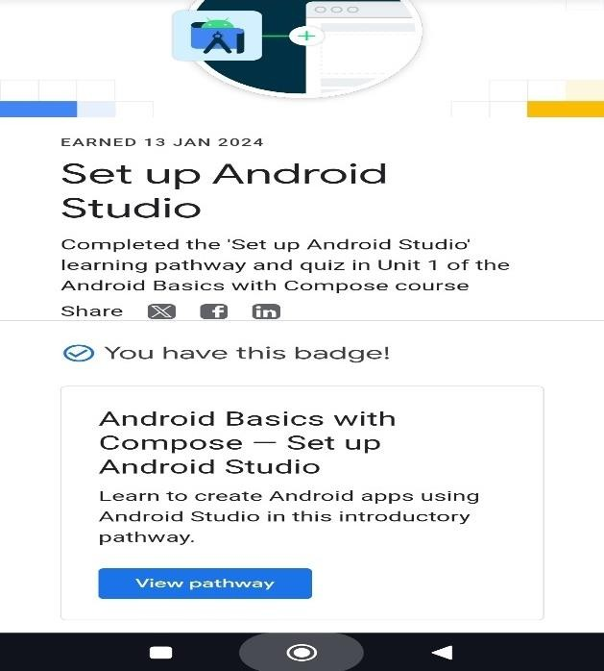 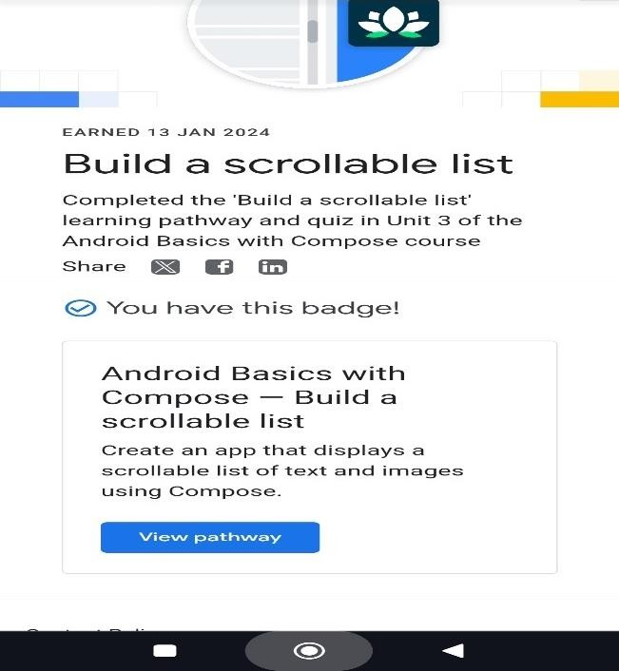

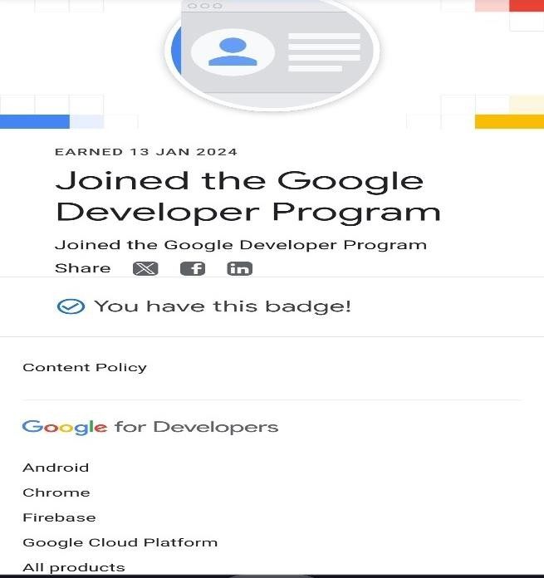

## ACTIVITY LOG FOR WEEK-4

|  |  |  |  |
| --- | --- | --- | --- |
| **Day & Date** | **Brief description of the daily activity** | **Learning Outcome** | **Person In Charge**  **Signature** |
| Day -1  2-02-24 | Gone through the android views &  compose in views | Completed the half of the modules |  |
| Day-2 3-02-24 | I have gone through the android views & compose in views | Completed the modules |  |
| Day-3 4-02-24 | Gone through load & display from the internet. | Completed the half of the modules. |  |
| Day-4 5-02-24 | Gone through load & display from the internet. | Completed the module. |  |
| Day-5  6-02-24 | Gone through the more Kotlin fundamentals. | Completed the half of the module |  |
| Day-6 7-02-24 | Gone through the more Kotin fundamentals | Completed the module. |  |

# WEEKLY REPORT-4

WEEK-4 (From 2/02/2024 to 7/02/2024)

**Objective of the Activity Done:** Gone through the modules.

**Detailed Report:** Gone through the android views & compose in views. Gone through the load & display from the internet. Gone through the more Kotlin fundamentals. Completed the modules.

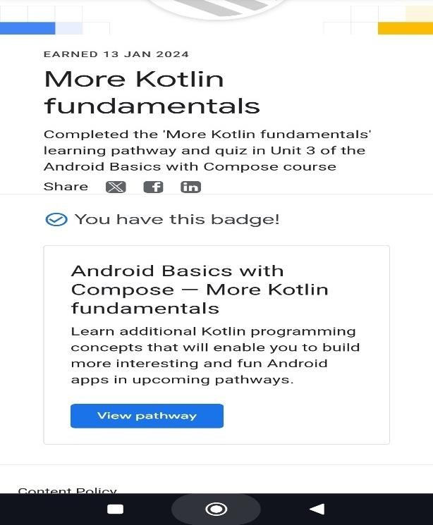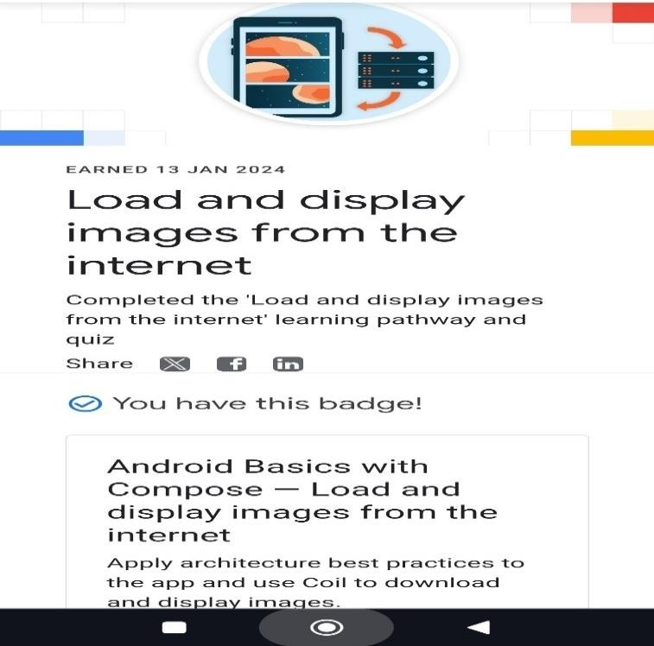

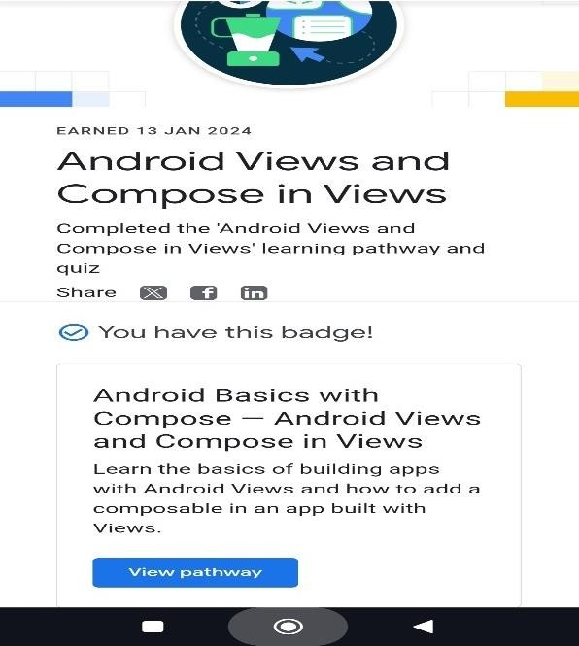

## ACTIVITY LOG FOR WEEK-5

|  |  |  |  |
| --- | --- | --- | --- |
| **Day & Date** | **Brief description of the daily activity** | **Learning Outcome** | **Person In**  **Charge Signature** |
| Day -1  8-02-24 | Gone through the first learning pathway & quiz badge. | Completed the half of the modules |  |
| Day-2 9-02-24 | I have gone through the first learning pathway & quiz badge. | Completed the modules |  |
| Day-3 10-02-24 | Gone through the architecture components | Completed the half of the modules. |  |
| Day-4 11-02-24 | Gone through architecture components | Completed the module. |  |
| Day-5  12-02-24 | Gone through the Build a basic layout. | Completed the half of the module |  |
| Day-6  13-02-24 | Gone through the built a basic layout. | Completed the module. |  |

# WEEKLY REPORT-5

WEEK-5 (From 8/02/2024 to 13/02/2024)

**Objective of the Activity Done:** Gone through the modules.

**Detailed Report:** Gone through the first learning pathway & quiz badge. Gone through the architecture components Gone through the the built a basic layout. Completed the modules.

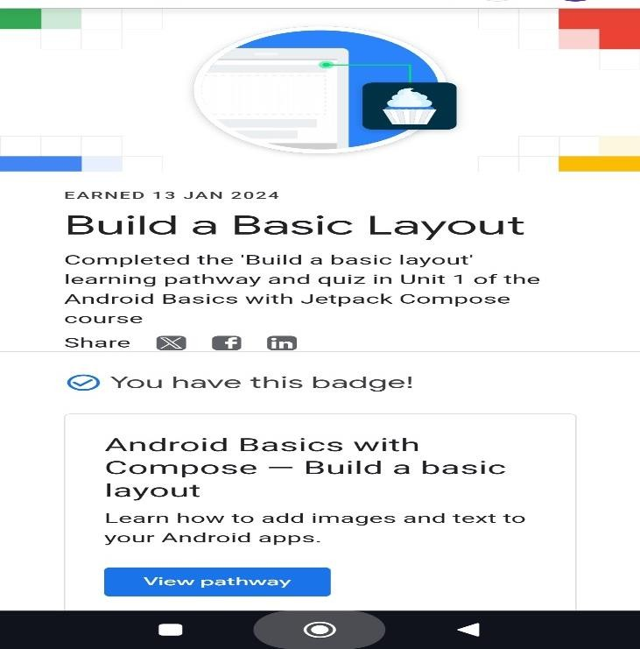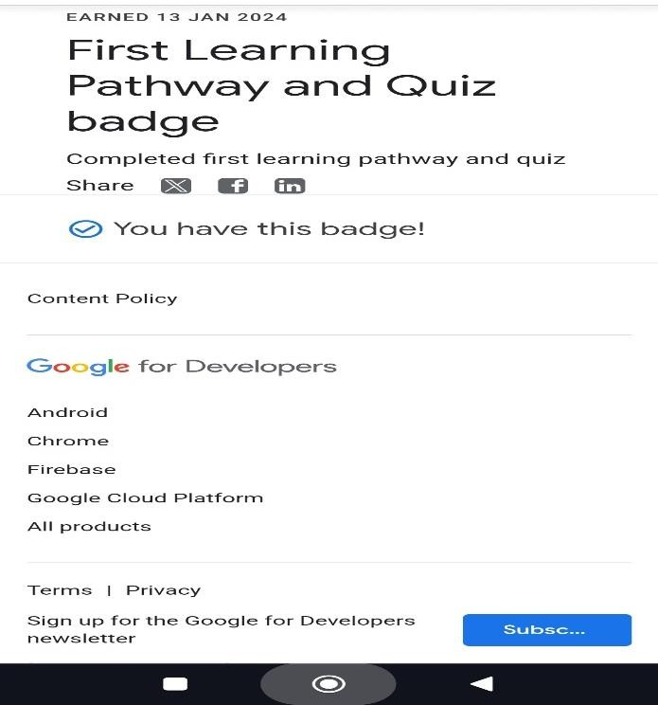

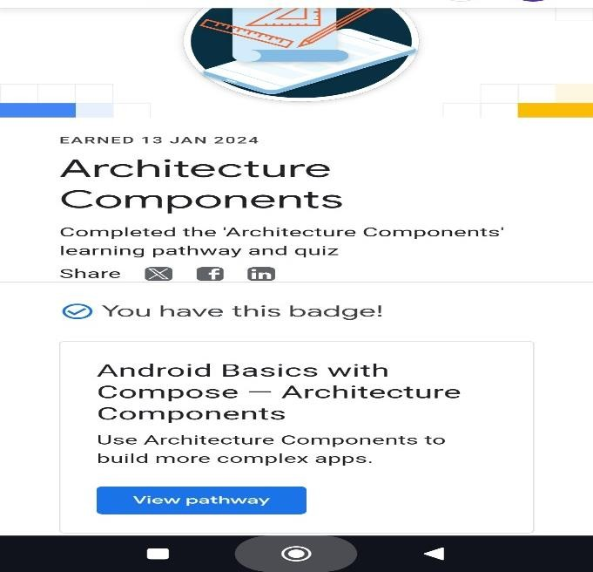

## ACTIVITY LOG FOR WEEK-6

|  |  |  |  |
| --- | --- | --- | --- |
| **Day & Date** | **Brief description of the daily activity** | **Learning Outcome** | **Person In Charge**  **Signature** |
| Day -1  14-02-24 | Gone through adaptive layouts. | Completed the half of the modules |  |
| Day-2 15-02-24 | I have gone through the adaptive layouts. | Completed the modules |  |
| Day-3 16-02-24 | Gone through the add a button to an app. | Completed the half of the modules. |  |
| Day-4 17-02-24 | Gone through add a button to an app. | Completed the module. |  |
| Day-5  18-02-24 | Gone through the completed the 25+codelabs. | Completed the codelabs. |  |
| Day-6  19-02-24 | Gone through add theme & animation. | Completed the module. |  |

# WEEKLY REPORT-6

WEEK-6 (From 14/02/2024 to 19/02/2024)

**Objective of the Activity Done:** Gone through the modules.

**Detailed Report:** Gone through the adaptive layouts. Gone through the add a button to an app. Gone through the completed the 25+codelabs. Gone through add theme & animation. Completed the modules.

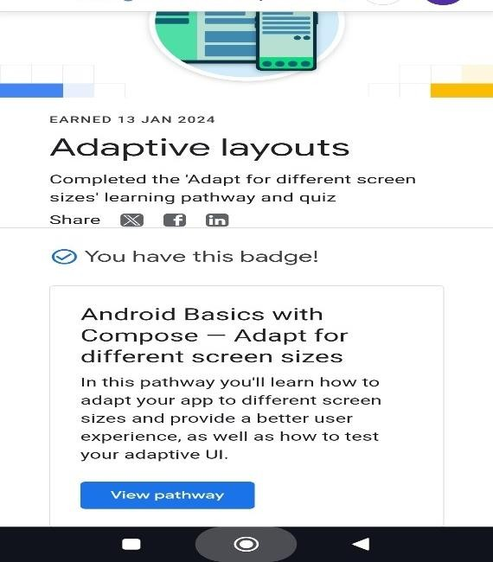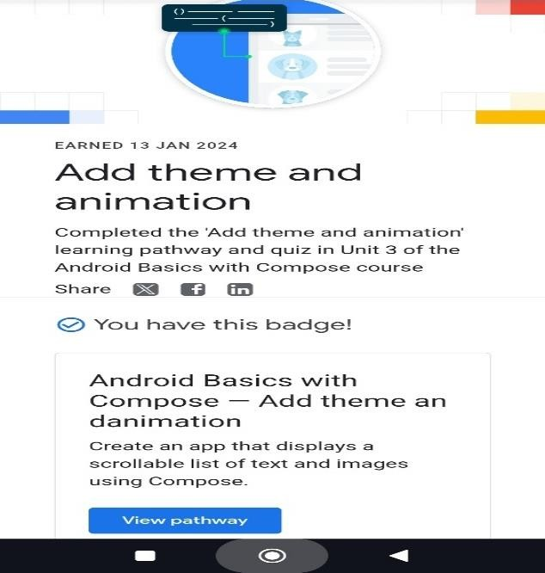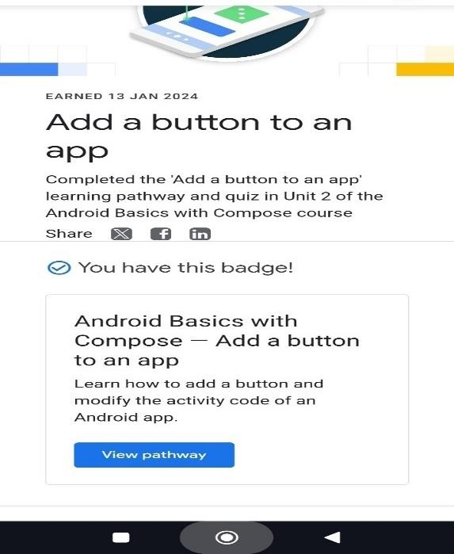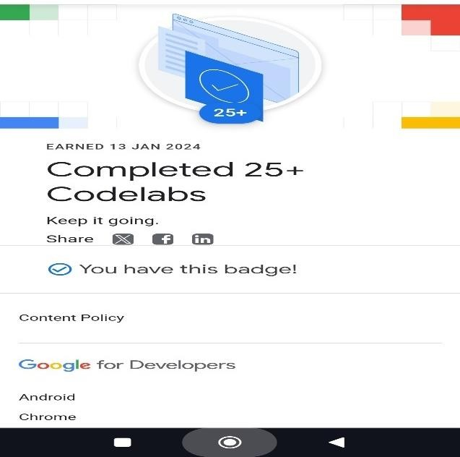

## ACTIVITY LOG FOR WEEK-7

|  |  |  |  |
| --- | --- | --- | --- |
| **Day & Date** | **Brief description of the daily activity** | **Learning Outcome** | **Person In Charge**  **Signature** |
| Day -1  20-02-24 | Gone through Navigation in jetpack  compose. | Completed the modules |  |
| Day-2 21-02-24 | I have gone through Schedule tasks with work manager. | Completed the half of the modules. |  |
| Day-3 22-02-24 | Gone through the Schedule tasks with  work manager. | Completed the modules. |  |
| Day-4 23-02-24 | Gone through views in compose | Completed the half of module. |  |
| Day-5  24-02-24 | Gone through views in compose | Completed the module. |  |
| Day-6  25-02-24 | Gone through interacting with UI &  state | Completed the module. |  |

# WEEKLY REPORT-7

WEEK-7 (From 20/02/2024 to 25/02/2024)

**Objective of the Activity Done:** Gone through the modules.

**Detailed Report:** Gone through Navigation in jetpack compose. gone through Schedule tasks with work manager. Gone through views in compose.Gone through interacting with UI & state. Completed all the modules.

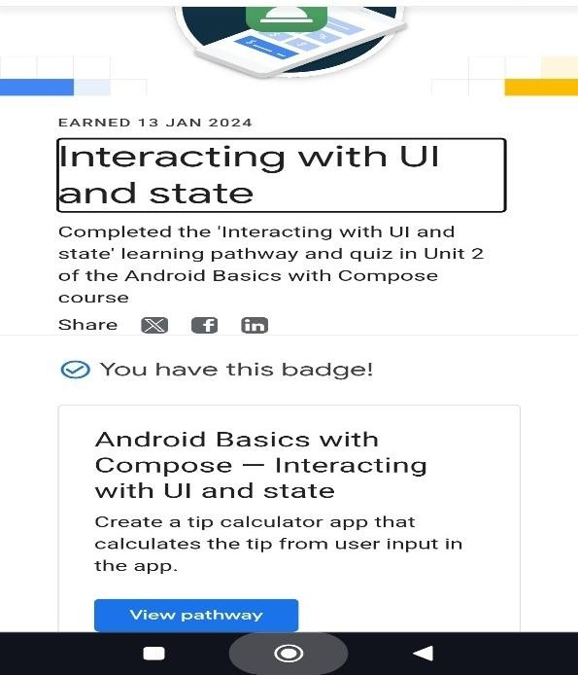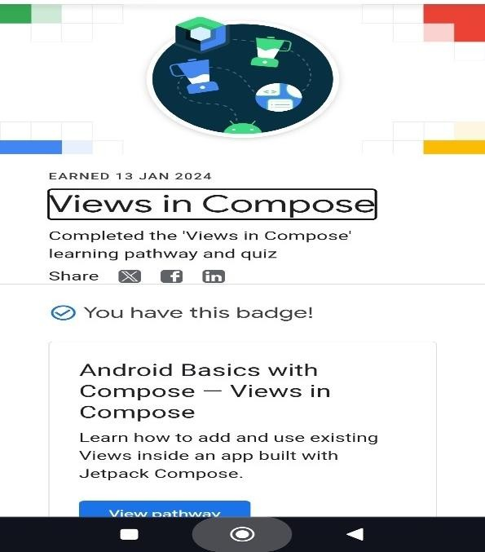

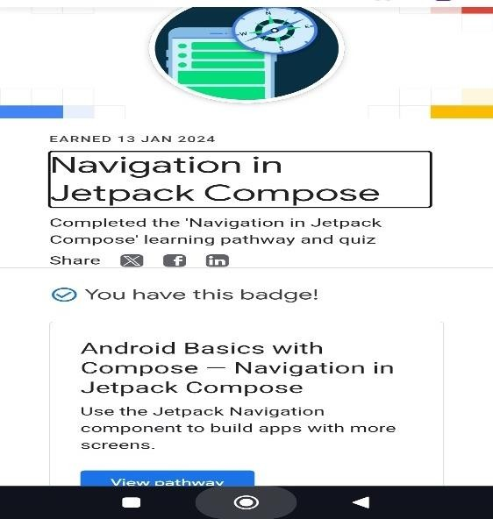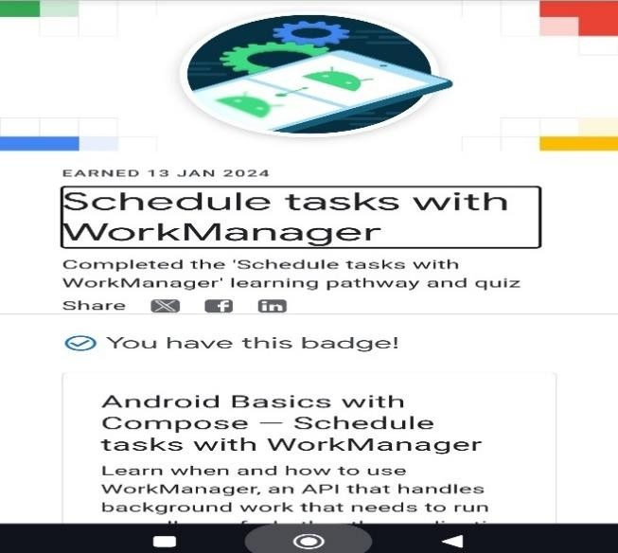

## ACTIVITY LOG FOR WEEK-8

|  |  |  |  |
| --- | --- | --- | --- |
| **Day & Date** | **Brief description of the daily activity** | **Learning Outcome** | **Person In Charge**  **Signature** |
| Day -1  26-02-24 | Gone through get data from the internet | Completed the modules |  |
| Day-2 27-02-24 | I have gone through introduction to SQL | Completed the half of the modules. |  |
| Day-3 28-02-24 | Gone through the introduction to SQL | Completed the modules. |  |
| Day-4 29-02-24 | Gone through use room for data persistence. | Completed the half of module. |  |
| Day-5  1-03-24 | Gone through use room for data persistence | Completed the module. |  |
| Day-6  2-03-24 | Gone through introduction to programming kotlin | Completed the module. | **`** |

# WEEKLY REPORT-8

WEEK-8 (From 26/02/2024 to 2/03/2024)

**Objective of the Activity Done:** Gone through the modules.

**Detailed Report:** Gone through get data from the internet. Gone through the introduction to SQL. Gone through use room for data persistence.Gone through introduction to programming Kotlin.

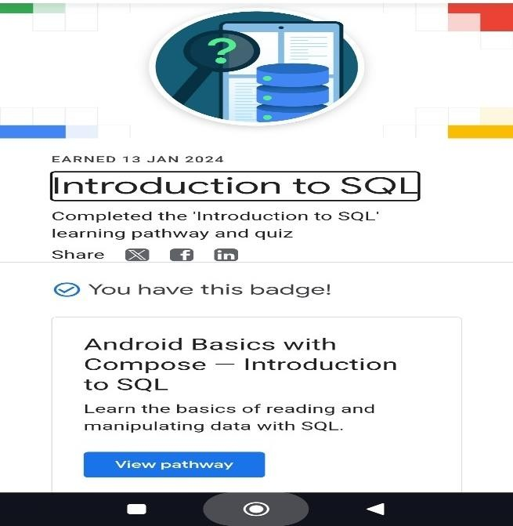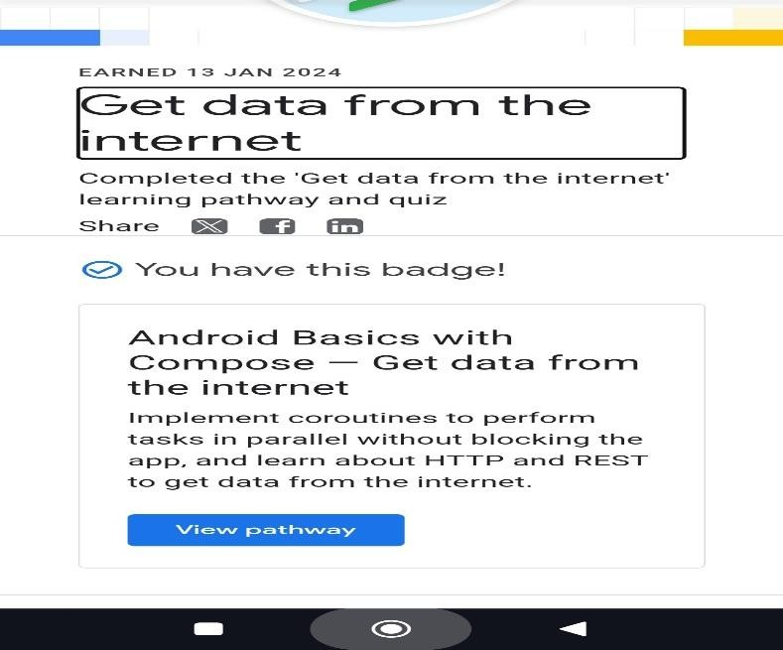

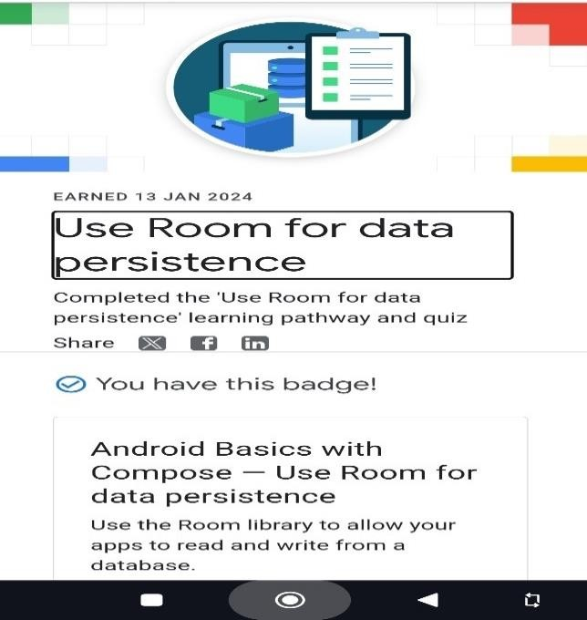 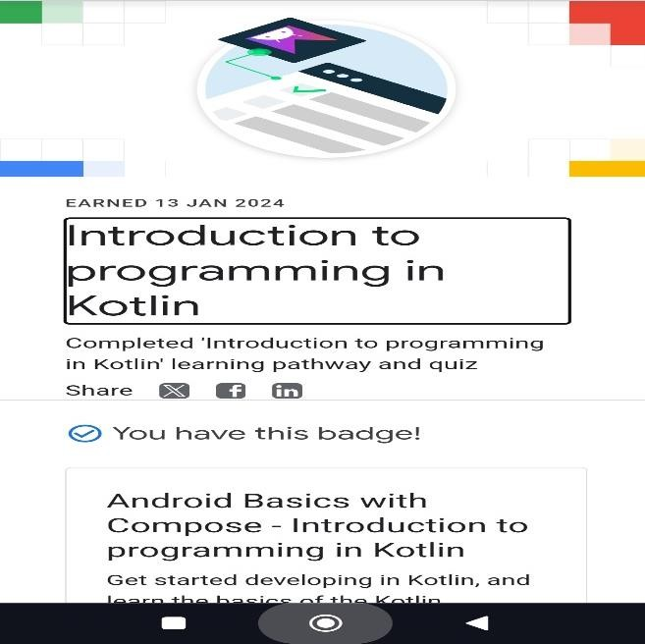

## ACTIVITY LOG FOR WEEK-9

|  |  |  |  |
| --- | --- | --- | --- |
| **Day & Date** | **Brief description of the daily activity** | **Learning Outcome** | **Person In Charge**  **Signature** |
| Day-1 3-03-24 | Gone through google developer website. | Opening website. |  |
| Day-1 3-03-24 | Gone through the google developer profile. | Checking the profile. |  |
| Day  3-03-24 | Gone through the Settings icon. | Checking the settings. |  |
| Day  3-03-24 | Gone through the updating profile | Updating profile. |  |
| Day  3-03-24 | Verifiying the badges details. | Verificataion. |  |
| Day  3-03-24 | Create custom web address. | Customizing the address in profile. | **`** |

# WEEKLY REPORT-9

WEEK-9 (3/03/2024)

**Objective of the Activity Done:** Gone through verification & updatation.

**Detailed Report:** Gone through google developer website. Gone through the google developer profile. Gone through the Settings icon. Gone through the updating profile. Verifiying the badges details. Create custom web address.

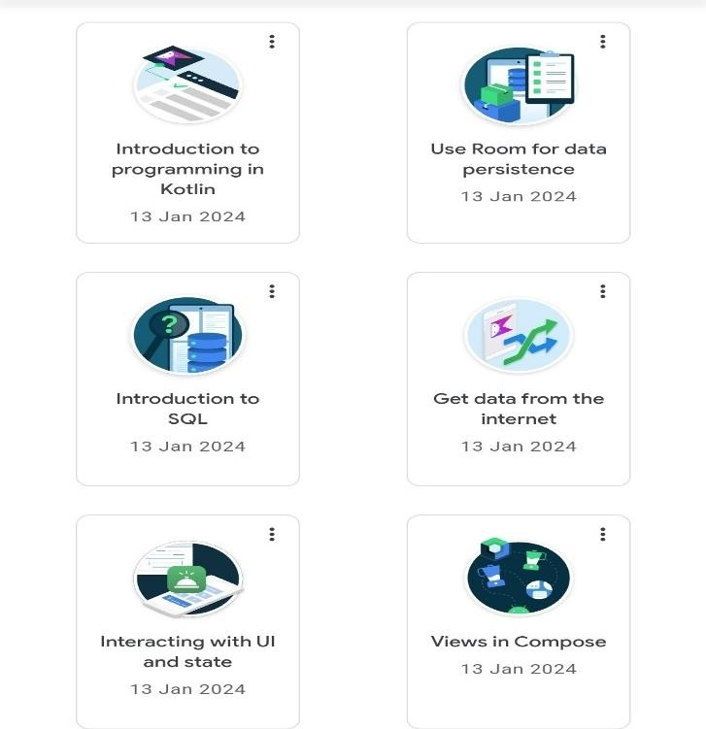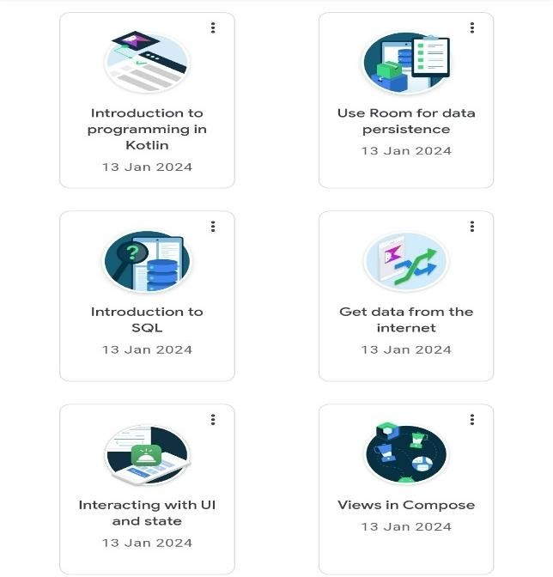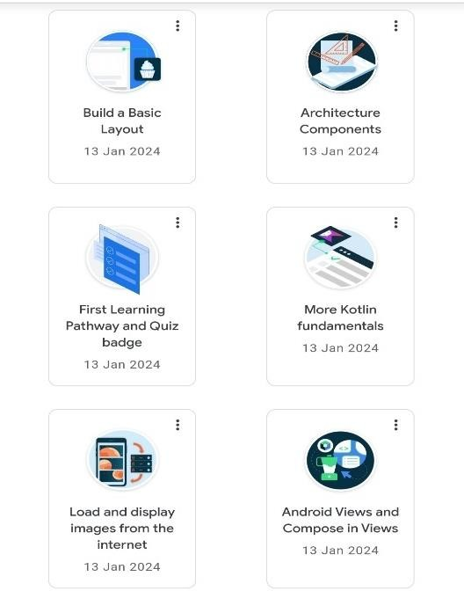

**ACTIVITY LOG FOR WEEK-10**

|  |  |  |  |
| --- | --- | --- | --- |
| **Day & Date** | **Brief description of the daily activity** | **Learning Outcome** | **Person In Charge**  **Signature** |
| Day -1  4-03-24 | Gone through certificate verification  portal. | Certification verification process. |  |
| Day-2  5-03-24 | Update the google developer profile account and should placed in public mode. | Checking the profile. |  |
| Day-3 6-03-24 | Created unique profile Address. | g.devyourname_collegename |  |
| Day-4 7-03-24 | Gone through certificate verification confirmation. |  |  |
| Day-5  8-03-24 | Gone through assessment | Assessment |  |
| Day-6 9-03-24 | Downloaded the certificate. | _ | **`** |

# Weekly report-10

## Week-10(4-03-24 to 9-03-24)

**Objective of the Activity Done:** Gone through assessment and downloading certificate.

**Detailed Report:** Gone through certificate verification portal. Update the google developer profile account and should placed in public mode. Created unique profile Address. Gone through certificate verification confirmation. Gone through assessment. Downloaded the certificate.

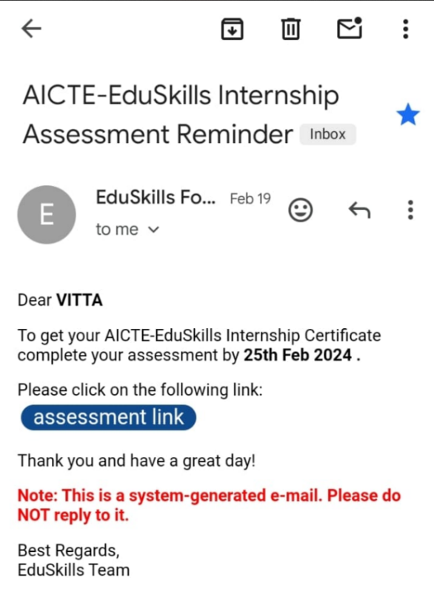 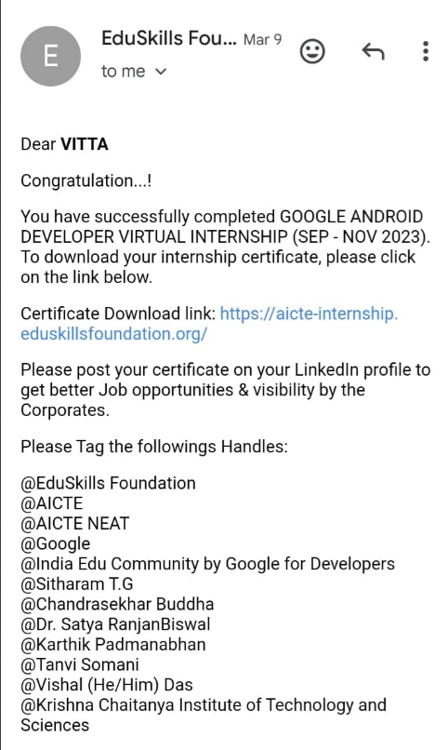

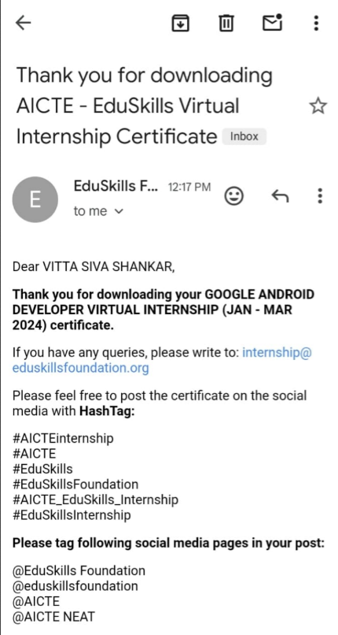 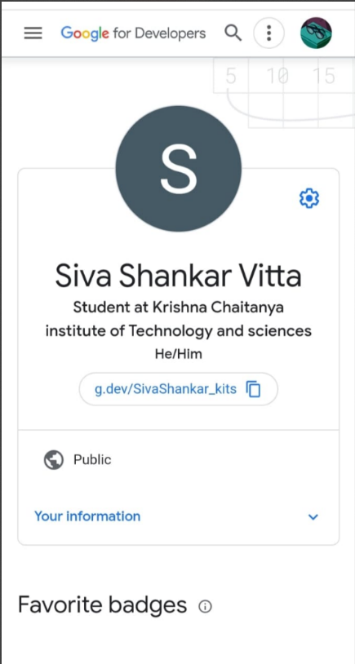

# Chapter5-outcomes description

## Describe the work environment you have experienced:

The culture at the company ensures that everyone feels supported and welcome. People genuinely want you to succeed and feel confident in your job. I learned a lot and felt set up to succeed at my next job. I'm so impressed with EduSkills foundation-AICTE. I've never worked at a place that offered me so much flexibility in how I use/spend my benefits, my hours, my work location, etc. Management is very supportive and leadership has an open door. Things move fast, so that can be different for people, but the trade- off is that you're doing work that really matters. You can consider yourself lucky when joining this company. Products are excellent. It’s a leader in the field. Culture is inclusive and friendly. The benefit package is one of the best out there.

EduSkills Foundation used to have an amazing culture but that has slipped away. The company touts care for yourself but in practice, most people I have worked with throughout the company are constantly stressed out at work and do not have a good work- life balance if they are able to deliver on the expectations of work. understanding politics is alsoextremely helpful. With all that said there is constant change and the company is growing quickly. There are plenty of learning opportunities and if you are lucky enough to get a good manager/team the experience may differ. IBM Skills Build is rated 4.7 out of 5, based on 10 reviews by employees on Ambition Box. IBM Skills Build is known for Job Security which is rated at the top and given a rating of 4.7. However, Career growth is rated the lowest at 4.0 and can be improved. The company hada GREAT work culture and strong technology. It still has strong technology but the culture has changed rather dramatically over the last four or five years. It's also grown by about 3x in that time, and some culture change is natural in that sort of accelerated growth mode. Still, there used to be a bit of a work-life there are quite smart and hardworking. It just got to be much more of a grind in the pandemic. And working fully remote didn't help that much. About 53% of the employees at EduSkills Build work 8 hours or less, while

7% of them have an extremely long day - longer than twelve hours. Overall, the employees at EduSkills are extremely happy, based on their aggregated ratings of future outlook, customer perception, and their excitement going to work.

I love what I do, which allows me to expand my technical knowledge constantly. I love that technology is constantly changing and I'm never bored. Eduskills is always striving to be the best in the market and this takes work. This takes work on everyone's part and I'm not disappointed in how this is accomplished by this company. It's still in a great place employee wise. Some “best of breed" technologies have gotten so large, they have lost their way, their focus and have become so political internally that the customer, aka users aren't the priority anymore. I have worked for some of them too. Security was a career change for me a year ago and they tooka chance on me and all my technology background in different areas. I have no complaints. It was a great decision.

It provides benefits that put you in the driver’s seat giving you the final say of what you need and how you get it. We offer benefits and resources to meet you wherever you are in life to make sure you and your family are healthy, supported and protected. We value your health and provide options so you can choose what best supports your lifestyle and personal health goals. A variety of nationwide plans including Anthem Blue Cross, Kaiser Permanente, Dental Guard, VSP and more are available to youand your family. Our providers offer the flexibility you want and the coverage you need. Professional development is serious business at IBM Skills Build, where the Talent Development team offers 25+ courses to help employees boost their careers and develop leadership capability.

## Describe the real time technical skills you have acquired: -

Building Android applications requires a deep understanding of [programming](https://generalassemb.ly/coding) and design. When approaching a new technology for the first time, it often helps to break it down into pieces. If you’re an experienced web developer, many of the concepts and technologies involved in [Android app development](https://generalassemb.ly/education/android-development-for-beginners) will be analogous to things you already know – although building apps for mobile devices often requires mastery of a [number of](https://generalassemb.ly/education/front-end-web-development-remote-online) [more nuanced concepts](https://generalassemb.ly/education/front-end-web-development-remote-online). Mobile devices have smaller screens, simpler processors, and – in the case of Android – many different manufacturers. That means that developers need to keep code flexible and account for various user interface scenarios.

## Java

* Java is the programming language that underpins all Android development**.** For those who have gained most of their programming experience in languages like [JavaScript](https://generalassemb.ly/education/javascript-development-remote-online) and Ruby, there can be a learning curve when picking up the Java programming language for the first time.
* Like JavaScript and Ruby, Java is object-oriented, but it is also stricter about handling data types. [Developers](https://generalassemb.ly/education/front-end-web-development-remote-online) have to be much more thoughtful with their code, defining the types of data their mobile applications plan to work with and more carefully allocating scarce memory resources.
* “You can’t afford to have ambiguity in a mobile environment, and Java makes sure that there’s no confusion about what each component of your application is trying to do,” says [James Traver](https://blog.generalassemb.ly/instructor-spotlight-life-long-coder-teaches-wdi-in-chicago/), a seasoned Android developer who’s taught the [Software Engineering](https://generalassemb.ly/education/software-engineering-immersive) [Immersive](https://generalassemb.ly/education/software-engineering-immersive) at GA. “You end up writing less code, but your code is more elegant and precise.”

## Understanding of XML: Building Android UI

* + XML was created as a standard way to encode data for internet-based mobile applications. It is a structured markup language, sharing many features in common with HTML – you may recognize the angled brackets, the <opening> and </closing> tag types, and the deep nesting of elements.
  + In short, it allows information to be passed between devices in a way that can be understood consistently. In the Android world, developers use XML to create layouts that serve as the foundational UI definition for Android applications.
  + Developers can also write Java code that modifies layout elements once the Android application is already running, in the same way that web developers use [JavaScript](https://generalassemb.ly/education/javascript-development) to modify the elements in their website at runtime. But mastering the basics of XML is an important skill for Android developers.

## Android SDK

* SDK stands for Software Development Kit, which, though it may conjure up images of a briefcase full of spy tools, is actually just a fancy name for a set of pre-packaged code. The Android SDKs are modules of Java code that give developers access to mobile device functions like the camera and accelerometer.
* One key component of the Android SDK is a library called Gradle. Let’s say that you want to integrate a social media platform like Facebook with your app. You would download a code library (or SDK) from Facebook, and then tell Gradle that you’re using it so that when your application compiles, your code stays well organized. New Android developers will spend much of their time discovering how the various SDKs for Android can be pieced together in different ways to put together an Android application.
* While this will take time, each Android SDK comes with many examples that can be found in the official documentation, making it easy to understand what each package does and how to plug it into your app.

## Android Studio

* The integrated development environment (IDE) of choice for Android developers is called Android Studio. Android Studio is built on top of the well-respected IntelliJ IDE, and it comes with great out-of-the-box support for many of the most common Android SDKs.
* Android Studio also features many of the capabilities developers expect of a full-featured IDE. Code completion helps make auto-complete suggestions as you type. Code debuggers let you step through your code to identify the source of errors.
* There are even more advanced tools like memory and CPU monitors, helping developers make sure their code will maintain high performance on a mobile device. Android Studio is a must have for both the beginner and experienced Android developer.

## APIs

* As an Android app developer, you’ll likely want to interact with many other services. For example, you may want to allow your users to access a calendar from a third party service, or check the stock market.
* An Android app development company usually offers APIs, and will tell you exactly how to query them for data in a consistent, secure way. While you’re free to interact with any existing API, Google also makes it very easy to connect to their own APIs from your Android app.
* For example, you can easily use Google APIs to monitor the location of your users, let them search for local places, and reference a map from within your application. You’ll want to get comfortable exploring the nuances of different APIs, and recognize that no two APIs are exactly alike.

## Databases

* If your app handles large amounts of data, most of it probably won’t live on your device at any given time. Instead, your app will likely interact with a database living outside of your phone. Cloud services like Firebase or Parse provide simple APIs to store data in the cloud and make it available across devices.
* These platforms also often provide Java libraries that you can plug into your app, making it easy to cache some of the data on the user’s device. This syncing of data between local storage and the remote database is important if you want to let users use the app when they’re offline.
* Another way to store data locally is through Android’s built-in support for using SQL to interact with a SQLite database. However you choose to handle data in your application, you’ll need to explore and understand how databases work, and the ways to query that data to use it in your app.

## Material Design

* In contrast to competitors like Apple, Google has not historically maintained a consistent design aesthetic across their products. In recent years, that has changed. Google has released a set of forward-thinking interface guidelines and standards called Material Design, that are being rolled out across all their products.
* These standards include tips for how to layer various elements on the screen and use specific styles like drop shadows. You’ve probably seen Material Design in real life if you’ve used a Google app.
* While not mandatory, Google recommends that Android developers use these guidelines as a foundation for their own user interfaces. The [documentation online](https://material.io/develop/android) provides a great foundational understanding of Material Design principles.

## Android UI

* An application is incomplete if it lacks modern UI. An application may contain useful functionalities, but if it fails to adapt to modern UI guidelines, then it is ultimately doomed to fail.
* Using Recycler View to implement lists and grids, using [Constraint Layout](https://app.pluralsight.com/library/courses/android-fundamentals-constraint-layout/table-of-contents) for designing complex layouts, [applying animations](https://app.pluralsight.com/library/courses/android-animations-update/table-of-contents) to enhance user experience, using appropriate [menus](https://app.pluralsight.com/library/courses/android-fundamentals-menus/table-of-contents), following [Material design](https://app.pluralsight.com/library/courses/android-material-design-getting-started/table-of-contents) guidelines and using [vector drawable’s](https://app.pluralsight.com/library/courses/android-kotlin-apps-resources-styles-themes/table-of-contents) instead of raster graphics are a few of the basic rules that every developer must follow in their apps.
* While designing layouts one must not forget to consider the [multiple screen type devices](https://app.pluralsight.com/library/courses/android-designing-layouts-multiple-device-screens/table-of-contents). The same app should look different for different devices. For example, the screen on a tablet should show dual-pane layouts to effectively utilize a widescreen. While on a smartphone it should use single pane. This behavior can be achieved by using [Fragments](https://app.pluralsight.com/library/courses/android-fundamentals-fragments/table-of-contents). Additionally, in several cases, you might need to customize Views that suit your need. This can be achieved by designing [custom components](https://app.pluralsight.com/library/courses/android-apps-kotlin-custom-views/table-of-contents) for your Views.

## Describe the managerial skills you have acquired:

There is a wide range of skills that management should possess to runan organization effectively and efficiently. The following are six essential management skills that any manager ought to possess for them to perform their duties:

## Planning:

Planning is a vital aspect within an organization. It refers to one’s ability to organize activities in line with set guidelines while still remaining within the limits of the available resources such as time, money, and *labour*. It is also the process of formulating a set of actions or one or more strategies to pursue and achieve certain goals or

objectives with the available resources. The planning process includes identifying and setting achievable goals, developing necessary strategies, and outlining the tasks and schedules on how to achieve the set goals. Without a good plan, little can be achieved.

## Communication:

Possessing great communication skills is crucial for a manager. It can determine how well information is shared throughout a team, ensuring that the group acts as a unified workforce. How well a manager communicates with the rest of his/her team determines how well outlined procedures can be followed, how well the tasks and activities can be completed, and thus, how successful an organization will be. Communication involves the flow of information within the organization, whether formal or informal, verbal or written, vertical or horizontal, and it facilitates the smooth functioning of the organization. Clearly established communication channels in an organization allow the manager to collaborate with the team, prevent conflicts, and resolve issues as they arise. A manager with good communication skills can relate well with the employees and, thus, be able to achieve the company’s set goals and objectives easily.

## Decision-making:

Another vital management skill is decision-making. Managers makenumerous decisions, whether knowingly or not, and making decisions is a key component in a manager’s success. Making proper and right decisions results in the success of the organization, while poor or bad decisions may lead to failure or poor performance. For the organization to run effectively and smoothly, clear and right decisions should be made. A manager must be accountable for every decision that they make and also be willing to take responsibility for the results of their decisions. A good manager needs to possess great decision-making skills, as it often dictates his/her success in achieving organizational objectives.

## Delegation:

Delegation is another key management skill. Delegation is the actof passing on work-related tasks and/or authorities to other employees or

subordinates. It involves the process of allowing your tasks or those of your employees to be reassigned or reallocated to other employees depending on current workloads. A manager with good delegation skillsis able to effectively and efficiently reassign tasks and give authority to the right employees. When delegation is carried out effectively, it helps facilitate efficient task completion. Every manager must have good delegation abilities to achieve optimal results and accomplish the required productivity results.

## Problem-solving:

Problem-solving is another essential skill. A good manager must have the ability to tackle and solve the frequent problems that can arise in a typical workday. Problem- solving in management involves identifying a certain problem or situation and then finding the best way to handle the problem and get the best solution. It is the ability tosort things out even when the prevailing conditions are not right. When it is clear that a manager has great problem-solving skills, it differentiates him/her from the rest of the team and gives subordinates confidence in his/her managerial skills.

## Describing how I could I improve my communication skills: 1.Listening:

People want to know that they are being heard. Really listen to what the other person is saying, instead of formulating your response. Ask for clarification to avoid misunderstandings. At that moment, the person speaking to you should be the most important person in your life. Another important point is to have one conversation at a time. This means that if you are speaking to someone on the phone, do not respond to an email, or send a text at the same time. The other person will know that she doesn’t have your undivided attention.

## Who you are talking to matters:

It is okay to use acronyms and informal language when you are communicating with a buddy, but if you are emailing or texting your boss,

“Hey,” “TTYL” or any informal language, has no place in your message. You cannot assume that the other person knows what the acronym means. Some acronyms have different meanings to different people, do you want to be misunderstood? Effective communicators target their message based on who they are speaking to, so try to keep the other person in mind, when you are trying to get your message across.

## Body language matters:

This is important for face-to-face meetings and video conferencing. Make sure that you appear accessible, so have open body language. This means that you should not cross your arms. And keep eye contact so that the other person knows that you are paying attention.

## Check your message before you hit send:

Spell and grammar checkers are lifesavers, but they are not fool proof. Double check what you have written, to make sure that your words are communicating the intended message.

## Be brief, yet specific:

For written and verbal communication, practice being brief yet specific enough, that you provide enough information for the other person to understand what you are trying to

say. And if you are responding to an email, make sure that you read the entire email before crafting your response. With enough practice, you will learn not to ramble, or give way too much information.

## Write things down:

Take notes while you are talking to another person or when you are in a meeting, and do not rely on your memory. Send a follow-up email to make sure that you understand what was being said during conversation

## Student Self-Evaluation of the semester Internship

Student Name: VITTA SIVA SHANKAR

Registration No.: 20JU1A05E1

Term of internship: 10 weeks From:9-01-24 To:9-03-24

**Please rate your performance in the following areas:**

## Rating Scale: Letter grade of CGPA calculation to be provided

|  |  |  |  |  |  |
| --- | --- | --- | --- | --- | --- |
| 1 Oral communication | 1 | 2 | 3 | 4 | 5 |
| 2 Written communications | 1 | 2 | 3 | 4 | 5 |
| 3 Proactiveness | 1 | 2 | 3 | 4 | 5 |
| 4 Interaction ability with community | 1 | 2 | 3 | 4 | 5 |
| 5 Positive Attitude | 1 | 2 | 3 | 4 | 5 |
| 6 Self-confidence | 1 | 2 | 3 | 4 | 5 |
| 7 Ability to learn | 1 | 2 | 3 | 4 | 5 |
| 8 Work Plan and organization | 1 | 2 | 3 | 4 | 5 |
| 9 Professionalism | 1 | 2 | 3 | 4 | 5 |
| 10 Creativity | 1 | 2 | 3 | 4 | 5 |
| 11 Quality of work done | 1 | 2 | 3 | 4 | 5 |
| 12 Time Management | 1 | 2 | 3 | 4 | 5 |
| 13 Understanding the Community | 1 | 2 | 3 | 4 | 5 |
| 14 Achievement of Desired Outcomes | 1 | 2 | 3 | 4 | 5 |
| **15 OVERALL PERFORMANCE** | **1** | **2** | **3** | **4** | **5** |

Date: Signature of the Student

**EVALUATION BY SUPERVISOR OF THE INTERN ORGANIZATION**

Student Name: VITTA SIVA SHANKAR

Registration.No.:20JU1A05E1

Term of Internship:10 weeks from: 9-01-2024 To: 9-03-2024 Date of Evaluation:

Please rate the student’s performance in the following areas:

Please note that your evaluation shall be done independent of the student’s self- evaluationRating Scale: 1 is lowest and 5 is highest rank

|  |  |  |  |  |  |  |
| --- | --- | --- | --- | --- | --- | --- |
| 1 | Oral communication | 1 | 2 | 3 | 4 | 5 |
| 2 | Written communication | 1 | 2 | 3 | 4 | 5 |
| 3 | Proactiveness | 1 | 2 | 3 | 4 | 5 |
| 4 | Interaction ability with community | 1 | 2 | 3 | 4 | 5 |
| 5 | Positive Attitude | 1 | 2 | 3 | 4 | 5 |
| 6 | Self-confidence | 1 | 2 | 3 | 4 | 5 |
| 7 | Ability to learn | 1 | 2 | 3 | 4 | 5 |
| 8 | Work Plan and organization | 1 | 2 | 3 | 4 | 5 |
| 9 | Professionalism | 1 | 2 | 3 | 4 | 5 |
| 10 | Creativity | 1 | 2 | 3 | 4 | 5 |
| 11 | Quality of work done | 1 | 2 | 3 | 4 | 5 |
| 12 | Time Management | 1 | 2 | 3 | 4 | 5 |
| 13 | Understanding the Community | 1 | 2 | 3 | 4 | 5 |
| 14 | Achievement of Desired Outcomes | 1 | 2 | 3 | 4 | 5 |
| **15** | **OVERALL PERFORMANCE** | **1** | **2** | **3** | **4** | **5** |

**Date: Signature of the supervisor:**

## EVALUATION

**Internal Evaluation for Semester Internship (Virtual) Objectives:**

* + To integrate theory and practice.
  + To learn to appreciate work and its function towards the future.
  + To develop work habits and attitudes necessary for job success.
  + To develop communication, interpersonal and other critical skills in the future job.
  + To acquire additional skills required for the world of work.

**Assessment Model:**

* + There shall only be internal evaluation.
  + The Faculty Guide assigned is in-charge of the learning activities of the students and for the comprehensive and continuous assessment of the students.
  + The assessment is to be conducted for 100 marks.
  + The number of credits assigned is 4. Later the marks shall be converted into grades and grade points to include finally in the SGPA and CGPA.
  + The weightings shall be:
* Activity Log 25 marks
* Internship Evaluation 50 marks
* Oral Presentation 25 marks
  + Activity Log is the record of the day-to-day activities. The Activity Log is assessed on an individual basis, thus allowing for individual members within groups to be assessed this way. The assessment will take into consideration the individual student’s involvement in the assigned work.
  + While evaluating the student’s Activity Log, the following shall be considered –
  1. The individual student’s effort and commit
  2. The student’s integration and co-operation with the work assigned.
  3. The completeness of the Activity Log.
* The Internship Evaluation shall include the following components and based on Weekly Reports and Outcomes Description.

1. Description of the Work Environment.
2. Real Time Technical Skills acquired.
3. Managerial Skills acquired.
4. Improvement of Communication Skills.
5. Team Dynamics
6. Technological Developments recorded

# MARKS STATEMENT

**(To be used by the Examiners)**

## INTERNAL ASSESSMENT STATEMENT

**Name Of the Student:** VITTA SIVA SHANKAR

**Programme of Study:** Bachelor of Technology

**Year of Study:**4th year

**Group:** Computer Science & Engineering

**Register No/H.T.No:** 20JU1A05E1

**Name of the college:** krishna Chaitanya Institute of Technology & Sciences

**University:** JNTU,Kakinada

|  |  |  |  |
| --- | --- | --- | --- |
| **Sl.No** | **Evaluation Criterion** | **Maximum Marks** | **Marks Awarde d** |
| 1. | Activity Log | 25 |  |
| 2. | Internship Evaluation | 50 |  |
| 3. | Oral Presentation | 25 |  |
|  | GRAND TOTAL | 100 |  |

Date: Signature of the Faculty Guide

## Certified by

Date: Signature of the Head of the Department/Principal Seal: